2. House Number

21, Sliven, Aleko Konstantinov Str.

GPS N 42º41’00.7” and E 26º20’00.5”

The house is with 1 floor without basement.

We plan to measure whole house. We suppose that this is 1 zone.

4 PCH – brown; 2 CATS

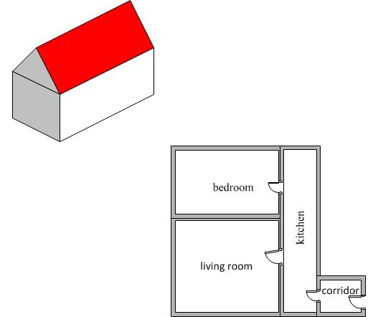

E-perm

pair of CATS

relevant GTS